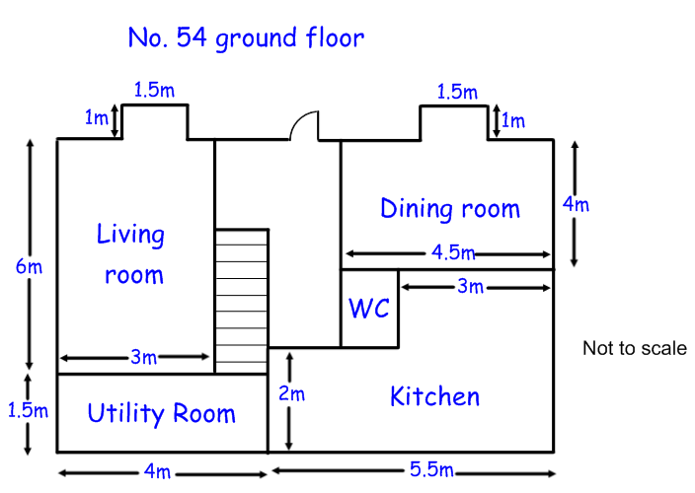
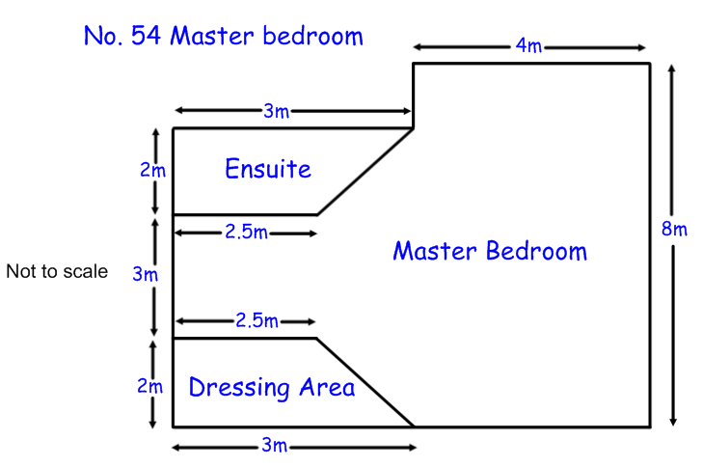
Floor plans – House No. 54

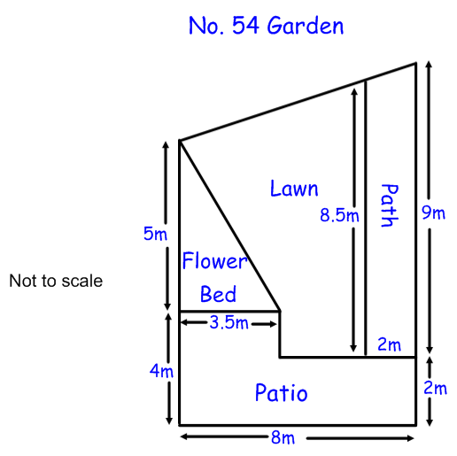

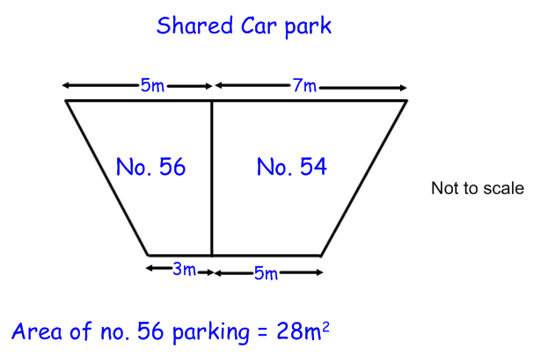

Floor plans – House no. 56
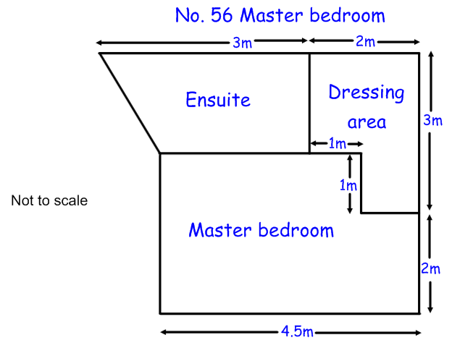
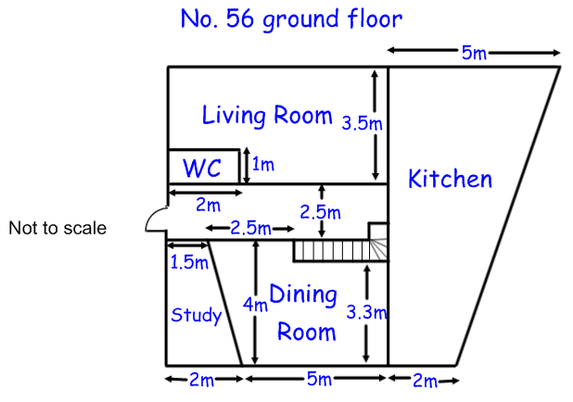

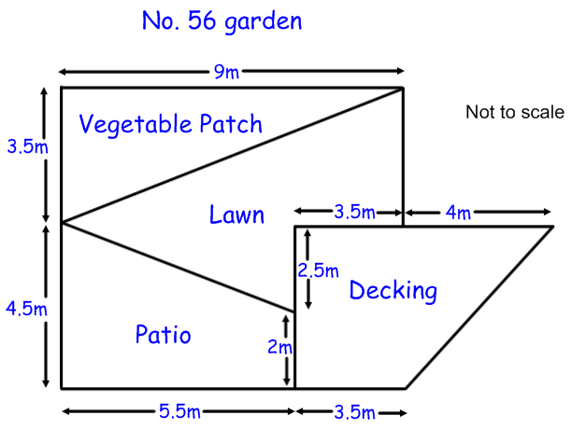

Area of composite shapes – floorplans
You should pick 3 of the bronze questions to answer. If you get all 3 correct, move on to the silver questions. If you get one wrong, try another one.
You should then pick 3 of the silver questions to answer. If you get all 3 correct, move on to the gold questions. If you get one wrong, try another one.
You should then attempt all of the gold questions.
Bronze questions

Bronze questions
- What is the total area of the living room in No.54?
- What is the area of the flower bed in no. 54’s garden?
- What is the area of the vegetable patch in no. 56’s garden?
- What is the area of the dressing area in no. 56’s master bedroom?
- What is the area of the living room in no. 56?
- What is the total area of the ground floor of house no. 54?

Silver Questions
- What is the area of the kitchen in No. 54?
- What is the area of the dressing area in No. 54’s master bedroom?
- What is the area of no. 56’s kitchen?
- Which house has a bigger living room? By how much?
- Which master bedroom has a bigger en-suite? By how much?
- Which garden has a bigger patio? By how much?

Gold questions
- Which house has the bigger dining room? By how much?
- What is the area of the master bedroom in no. 54 (excluding en-suite and dressing room)?
- What area of no. 54’s garden is laid to lawn?
- What is the area of no. 54’s parking?
- What area of no. 56’s garden is laid to lawn? Convert your answer to cm².
- Work out the total area of the ground floor of each house. Which is bigger? What percentage bigger?

