Plotting Straight Line Graphs

a) y = x + 5 b) y = x + 6
x
yx
01x
121x
2321x
x
yx
01x
121x
2321x

y
y
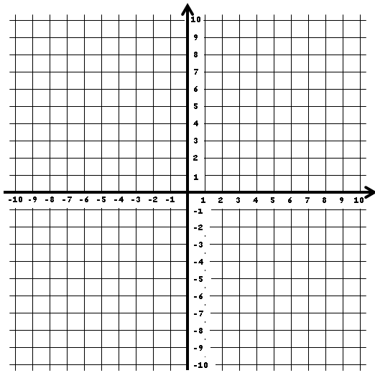

x
x

What is the gradient of the graph above? ___
What is the y-intercept? ___
Can you link this to the equation of the line?
__________________________________
What is the gradient of the graph above? ___
What is the y-intercept? ___
Can you link this to the equation of the line?
__________________________________

c) y = 2x + 1 d) y = 2x - 4
x
yx
01x
121x
2321x
x
yx
01x
121x
2321x

x
y
x
y
What is the gradient of the graph above? ___
What is the y-intercept? ___
Can you link this to the equation of the line?
__________________________________
What is the gradient of the graph above? ___
What is the y-intercept? ___
Can you link this to the equation of the line?
__________________________________

e) y = 3x + 2 f) y = 3x - 7
x
yx
01x
121x
2321x
x
yx
01x
121x
2321x

x
y
x
y

What is the gradient of the graph above? ___
What is the y-intercept? ___
Can you link this to the equation of the line?
__________________________________
What is the gradient of the graph above? ___
What is the y-intercept? ___
Can you link this to the equation of the line?
__________________________________

g) y = 10 - x h) y = 10 – 2x
x
yx
01x
121x
2321x
x
yx
01x
121x
2321x

x
y
x
y
What is the gradient of the graph above? ___
What is the y-intercept? ___
Can you link this to the equation of the line?
__________________________________
What is the gradient of the graph above? ___
What is the y-intercept? ___
Can you link this to the equation of the line?
__________________________________

i) y + x = 5 j) y + x = 7
x
y
x
y

What is the gradient of the graph above? ___
What is the y-intercept? ___
Can you link this to the equation of the line?
__________________________________
What is the gradient of the graph above? ___
What is the y-intercept? ___
Can you link this to the equation of the line?
__________________________________

k) 2y + x = 12 l) 2x + y = 12
y
x
x
y

What is the gradient of the graph above? ___
What is the y-intercept? ___
Can you link this to the equation of the line?
__________________________________
What is the gradient of the graph above? ___
What is the y-intercept? ___
Can you link this to the equation of the line?
__________________________________

What do you notice about the 2 equations for k) and l)? _________________________________
__________________________________________________________________________
What about the gradients of the lines? ____________________________________________
__________________________________________________________________________

y
Investigation: Plot an equation of your choice. Now, reverse the positions of the y and x, and plot the new graph on the same axes. What do you notice? Is this always true?

Equation I chose:

_______________________

Equation with x and y switched:

_______________________

x

Equation I chose:

_______________________

Equation with x and y switched:

_______________________
y
x

